Experiment Tracker
In not-for-profit governance, bold ideas often rise and fall on enthusiasm alone. A charismatic board member might execute an idea they are passionate about but fail to produce clear outcomes. The organisation might announce a new project or policy, run hard for a few months, and then quietly move on when the results are uncertain or mixed. This Experiment Tracker is designed to interrupt that cycle by helping teams to collaborate effectively and make data-informed decisions.
Real progress usually comes less from grand gestures and more from trial and error. Learning happens when we make our assumptions visible without being defensive, test them in the real world, and record what actually happens, not what we had hoped would happen.
This helpsheet provides a simple structure to support that process. It helps to turns idealism into evidence-based practice, and helps to replace defensiveness with curiosity. It helps your board or team to stay focused on learning rather than on protecting reputations or “winning” debates.
It can be used when you’re launching a new policy, campaign, project or partnership. The aim is to find what works and then to share those lessons transparently with others.

Describe what you’re trying and why.
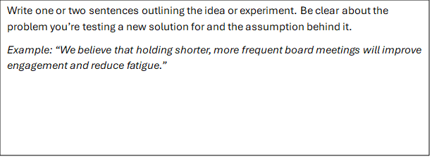

Describe what success would look like.
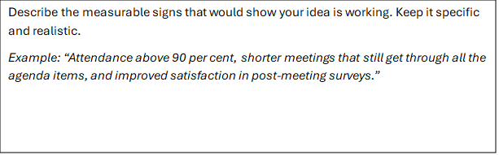

Plan what evidence you’ll gather and when.
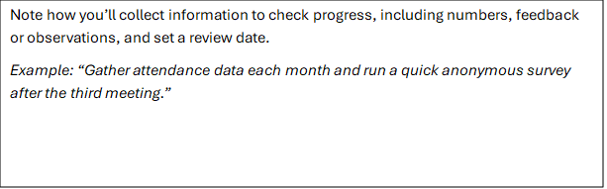

Review your results, and record what you’ll adjust in light of those results.
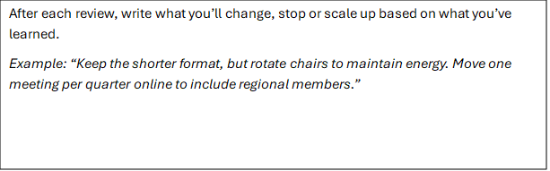

Share what you’ve learned.
